Dissertation Paper
Estimating Formula 1 Car Performance Through Predictive Analytics and Data Mining
Suliman Miruna
Department of Software Development and Business Information Systems, Faculty of Economics and Business
Administration, Alexandru Ioan Cuza University, Iasi, Romania
Dissertation coordinator: Prof. univ. Dr. Daniel Homocianu
Abstract: This study investigates whether Formula 1 drivers exhibit distinct behavioral styles and how these styles influence race outcomes. Leveraging high-resolution telemetry data from the 2021–2023 seasons, the research applies Principal Component Analysis (PCA) and K-means clustering to segment qualifying performance into three distinct driving styles: Aggressive, Balanced, and Cautious. These clusters are validated through hierarchical analysis and characterized by averages of throttle, brake, and speed. To evaluate whether these styles affect competitive success, the study constructs a predictive model of race outcomes using Random Forest classifiers trained on aggregated race-level features, including pace, consistency, and sector balance. By analyzing predictive performance separately within each style cluster, the results reveal that aggressive drivers exhibit more stable, modelable patterns of success, while cautious drivers demonstrate greater variability across contexts. The findings support a behavior-aware modeling approach, showing that the relationship between performance metrics and results is contingent on underlying driver behavior. This contributes new empirical evidence to the literature on motorsport analytics by linking telemetry-driven behavioral profiling with outcome prediction.
Keywords: Formula 1 telemetry; Driver behavior; Machine learning; Unsupervised clustering; PCA; Random Forest; Predictive modeling; Motorsports analytics; Driving styles.

1. Introduction
"Data is in the team's lifeblood. Every element of performance—how we run a race, how we develop a car, how we select and analyze drivers—it's all driven by data." - Christian Horner, CEO of Oracle Red Bull Racing (Marr, 2023).

This perspective from the head of a leading Formula 1 team encapsulates the sport’s transformation from an engineering-focused competition to a discipline defined by data-centric operations. Modern F1 teams operate as real-time analytics platforms, where technical and strategic decisions are informed by continuous telemetry rather than relying solely on mechanical intuition.

Contemporary Formula 1 cars operate as mobile data laboratories, equipped with over 300 telemetry sensors that generate approximately 1.5 billion data points per race weekend (Nimmala, 2024). These sensors capture intricate variables ranging from tire slip angles to combustion dynamics, facilitating rapid adjustments to tire pressures, fuel strategies, and aerodynamic setups under evolving track conditions. This data-rich environment offers immense analytical potential but also introduces significant interpretive challenges, particularly due to the high dimensionality and real-time nature of the information.

Yet here lies the central paradox: while data abundance creates unprecedented opportunities, the sheer volume of variables, from transient aerodynamic loads to compound-specific tire degradation, renders traditional analysis methods inadequate.

The complexity of this environment mirrors broader issues encountered in data science. Distinct yet complementary, data mining and machine learning offer separate toolkits for extracting insights. Data mining methods emphasize exploratory analysis and pattern recognition, such as uncovering latent driving styles or identifying consistent sector time trends. In contrast, machine learning prioritizes predictive accuracy, enabling outcome-focused applications like forecasting race finishes or modeling pit-stop impacts (Shu & Ye, 2022).

While analytics is well-established in sports such as football and basketball (J & Rastegari, 2013), motorsport research remains underdeveloped, often constrained by data accessibility and the proprietary nature of team operations. The present study aims to contribute to this emerging field by implementing a structured analytical framework grounded in publicly available telemetry data.

Research Focus and Hypotheses
Building on the dual nature of data-driven analysis, exploratory and predictive, this study investigates how telemetry data can be used to understand and forecast driver performance in Formula 1. The focus lies at the intersection of unsupervised behavioral segmentation and supervised outcome prediction, guided by the assumption that driving style moderates the relationship between performance metrics and competitive success.

Research Question
Can unsupervised and supervised learning techniques applied to qualifying and race telemetry data reveal distinct driving styles and predict race outcomes in a way that varies by behavioral profile?

Hypotheses
H₁: Formula 1 drivers exhibit distinct driving styles, such as aggressive, cautious, or balanced, that can be identified through unsupervised learning applied to qualifying telemetry data.

This hypothesis assumes that individual driving behaviors manifest in control-based telemetry metrics, such as throttle usage, braking intensity, and average speed. These features, captured during qualifying sessions, offer a relatively unconfounded representation of driving performance, as they are less influenced by strategic factors like tire conservation, traffic, or fuel loads. This makes qualifying telemetry especially suitable for revealing behavioral tendencies.
Support for this approach comes from empirical work in performance clustering and sports analytics. Duman et al. (2021) demonstrated how unsupervised learning can segment basketball players based on positional and behavioral metrics, while Cui et al. (2019) applied similar techniques to uncover performance profiles in tennis. In the motorsport domain, clustering high-dimensional telemetry data allows the emergence of style-based archetypes not imposed by labels, but derived from patterns in how drivers control their cars across circuits.
These behavioral clusters provide the foundation for further analysis of competitive outcomes, forming the theoretical basis for the second hypothesis.

H₂: The predictive influence of performance-related features on race outcomes varies across the driving style clusters established in H₁.

This hypothesis is grounded in the idea that driving styles condition the mechanisms through which competitive success is achieved. For example, aggressive drivers may extract advantage through peak pace and decisive control inputs, whereas cautious drivers may rely on consistency and risk-avoidance. These differences imply that the same performance indicators, such as average pace, pace variability, or sector balance, may hold different predictive value depending on the driver’s behavioral profile.
Literature such as Batikas et al. (2024) highlights the role of driver-circuit interac-tions and adaptive strategies in shaping race outcomes, suggesting that predictive models must be sensitive to individual styles. By modeling each behavioral cluster separately, this study tests whether the influence of features like average pace, con-sistency, and sector balance varies with underlying driver behavior.

Objectives
The study aims to evaluate how driver behavior and race performance metrics contribute to competitive success in Formula 1. For this purpose, success is operationally defined as scoring points (i.e., finishing in the top 10), which represents a practical and widely recognized benchmark in the sport. While other metrics such as final position, overtaking efficiency, or pit strategy optimization may also reflect success, this research focuses specifically on PointsFinish as the target variable due to its binary clarity and direct relevance to championship outcomes.

To test the proposed hypotheses and investigate this definition of success, the study sets out the following operational objectives:
- To extract and standardize relevant telemetry variables from qualifying and race sessions;
- To uncover latent patterns in driving behavior through unsupervised clustering techniques;
- To construct predictive models for race outcomes using features engineered from telemetry data;
- To analyze how the importance of these predictors differs between behavioral clusters.

Scope and Methodological Considerations
The analysis is limited to a representative sample of qualifying and race sessions across six diverse circuits, including street tracks (e.g., Monaco), high-speed layouts (e.g., Monza), and technical configurations. Subjective or non-telemetry-based factors, such as driver psychology, team orders, or weather variability, are deliberately excluded to maintain methodological focus.

From a methodological standpoint, the study adopts a quantitative, data-driven approach, combining unsupervised clustering (via PCA and K-means) with supervised classification models (Random Forests). Data preprocessing includes rigorous cleaning, imputation, and standardization procedures to ensure analytical robustness. The data originates from the FastF1 Python API and includes standardized metrics such as throttle input, braking force, and average speed.

The dissertation is organized as follows: after reviewing relevant literature on motorsport analytics and data modeling, the methodology chapter outlines the feature engineering, clustering, and predictive modeling procedures. The results chapters explore cluster formation, performance variability, and model behavior across driving styles, followed by a discussion of implications and future directions.

Contribution and Practical Implications
By integrating exploratory clustering with predictive modeling, this work contributes to a more granular understanding of how driver behavior interacts with race outcomes. The findings hold relevance for data analysts within motorsport teams, offering a blueprint for behavior-specific modeling approaches that extend beyond generic performance prediction. In a regulatory context shaped by cost caps and performance equalization, such techniques may offer competitive advantages for smaller teams seeking data-driven optimization strategies (Fédération Internationale de l'Automobile, 2025).

Ultimately, this research illustrates how telemetry-based modeling can serve not only to describe driving behavior but also to contextualize its competitive relevance—bridging the gap between exploratory insight and predictive utility in the evolving landscape of Formula 1 analytics.

2. Literature Review
This review examines the existing academic landscape concerning data mining and machine learning in sports analytics, with a focus on their application in Formula 1. While motorsport analytics shares foundational methods with traditional sports, F1 presents unique challenges due to its extreme data complexity (300+ real-time telemetry channels) (Nimmala, 2024), razor-thin competitive margins (where microscopic advantages determine outcomes) (Batikas, 2024), and growing dependence on predictive systems for strategic decisions.
The synthesis of exploratory data mining and predictive modeling has become especially valuable in this context. It enables teams to derive actionable insights from high-dimensional data streams while operating under increasingly restrictive financial constraints such as the FIA-mandated budget caps. This literature review traces developments in the use of both data mining and machine learning techniques across sport, with a focus on their adaptation to motorsport. By analyzing studies involving clustering strategies, predictive outcome modeling, and behavior segmentation, the review identifies both the methodological advancements and the remaining limitations in current motorsport analytics research.

Data Mining in Sports Analytics
Data mining, broadly defined as the extraction of meaningful patterns from large datasets (Han & Kamber, 2001), has long been employed across sports domains to support decision-making and performance optimization. In football, for example, Patil et al. (2023) describe the use of classification algorithms to anticipate match outcomes, while in basketball, Miljković et al. (2010) applied Naive Bayes classifiers with nearly 78% accuracy. Beyond forecasting, data mining techniques have proven instrumental in injury prevention, talent scouting, and tactical analysis. AC Milan’s integration of biomedical data mining tools to predict player injuries exemplifies its broader utility (Flinders, 2002).
In motorsports, data mining’s value is amplified by the sheer scale of telemetry generated by Formula 1 cars, with over 300 data channels capturing metrics such as throttle input, braking force, fuel consumption, and tire temperature (Nimmala, 2024). Early work in this space focused on lap-time simulation and trajectory modeling (Heilmeier, 2018), but the field has since evolved toward more exploratory applications.
One key area of development is unsupervised learning, particularly clustering methods used to identify latent behavioral profiles among drivers. While widely adopted in other sports—such as basketball and tennis—for grouping player types based on skill metrics (Cui et al., 2019; Duman et al., 2021), clustering remains underutilized in Formula 1. Batikas (2024) notes that telemetry-based behavioral segmentation is often absent from public analyses, despite its potential to uncover patterns such as high-speed driving styles or risk-averse braking strategies. These insights are directly relevant to Hypothesis H₁, which posits that F1 drivers exhibit identifiable driving styles during qualifying, detectable via clustering techniques applied to telemetry.

Machine Learning in Sports Analytics
While data mining excels at pattern discovery and exploratory segmentation, machine learning (ML) offers tools for predicting outcomes and quantifying the influence of input features on target variables. This predictive orientation makes ML particularly well-suited to Formula 1, where forecasting performance under varying conditions is both complex and mission-critical (Shu & Ye, 2022).
In related sporting contexts, ML models such as neural networks have shown strong performance in tasks like race result prediction for horse racing (Bishell, 2014) and match outcome forecasting in football (Patil et al., 2023). Within motorsports, Batikas (2024) highlights how supervised algorithms, such as support vector regression and LASSO regression, can predict pit-stop timing and optimize race strategy based on historical telemetry inputs.
However, most existing research in F1 still prioritizes predictive accuracy over interpretability. This trade-off is problematic when the goal is not only to forecast outcomes but also to understand why certain drivers succeed under specific conditions. For example, while a model may predict that a driver is likely to score points, it may not clarify whether this success stems from consistent lap times, peak performance capacity, or smooth sector transitions. This interpretability gap is especially relevant in the context of Hypothesis H₂, which proposes that the importance of performance features varies by driving style, thus requiring style-specific analysis of feature influence.

Integration of Data Mining and Machine Learning
The integration of data mining and machine learning represents a progressive paradigm in sports analytics, offering a dual framework that combines exploratory insight with predictive precision. While the two approaches serve different purposes, data mining aims to uncover latent patterns and structures in raw datasets, whereas machine learning focuses on predictive modeling based on statistical inference, their combination has proven particularly effective in complex, data-rich domains such as Formula 1 (Shu & Ye, 2022; Duman et al., 2021).
An integrative framework not only improves the interpretability of predictive models but also addresses the limitations inherent in using either approach independently. Data mining offers transparency and descriptive power, but lacks generalizability and outcome validation. Machine learning algorithms such as Random Forests and Support Vector Machines (SVMs), while highly effective for classification and regression tasks, often suffer from "black box" opacity (Raschka & Mirjalili, 2019). Their predictive decisions may be difficult to interpret without contextual scaffolding. Combining both approaches enable richer, more explainable models, especially important in Formula 1, where decisions made from model outputs must be rapidly trusted and operationalized.
Recent work in the broader field of sports analytics supports this convergence. For example, Cui et al. (2019) successfully combined clustering with predictive classification in tennis to segment player strategies before training a classifier to anticipate match outcomes. In basketball, Duman et al. (2021) integrated behavioral segmentation with shot prediction to improve tactical planning. However, similar multilayered analytical pipelines are rarely documented in motorsport literature, where most studies either emphasize time-series forecasting (Heilmeier, 2020) or focus exclusively on telemetry-driven classification tasks (Patil et al., 2023).

Identified Gaps
Despite notable advances in the application of data mining and machine learning to sports analytics, several methodological and empirical gaps persist in the literature, particularly with respect to Formula 1. Much of the current research either concentrates on lap-time simulation or race outcome prediction, while underexploring the behavioral and stylistic dimensions of driver performance that precede those outcomes (Patil et al., 2023; Heilmeier, 2020).
First, existing studies frequently prioritize predictive accuracy without sufficient emphasis on interpretability. For example, neural networks and other black-box models may achieve high forecasting performance but often fail to provide actionable insight into why certain features influence race outcomes (Raschka & Mirjalili, 2019). This lack of transparency limits their strategic utility for race engineers and decision-makers who require clear, interpretable justifications for deploying specific tactics during dynamic race conditions.
Second, while clustering techniques have been widely used in other sports domains to identify behavioral archetypes, their application to Formula 1 remains sparse. Existing clustering work in motorsport often focuses on strategy classification (e.g., pit stop grouping or tire selection), rather than segmenting drivers based on their in-lap behavioral telemetry. As a result, the literature has not yet systematically explored whether distinct driving styles can be inferred from qualifying data and whether these styles impact subsequent race outcomes differently.
Third, most Formula 1 research tends to isolate analysis at either the race or lap level, often overlooking the relationship between qualifying behavior and race performance. For example, while studies may model race outcomes based on tire degradation or weather conditions (Heilmeier, 2018), few link these predictions back to underlying behavioral typologies observed during earlier qualifying sessions. This limits understanding of how style-specific factors, such as aggression, consistency, or control, mediate the influence of pace-related features on race success.
Moreover, the interaction between behavioral segmentation and feature relevance remains largely unexplored. In other words, the question of whether certain performance metrics (e.g., average pace, pace consistency, sector balance) vary in predictive influence depending on a driver's style is seldom addressed. As suggested by Patil et al. (2023), such differentiated analyses are crucial for building more adaptive and context-aware predictive models in motorsport.
Finally, there is limited empirical research that synthesizes data mining’s exploratory segmentation capabilities with machine learning’s predictive power within an integrated pipeline. Studies that do apply both methodologies often treat them sequentially rather than strategically interlinked, missing the opportunity to leverage behavioral insights to tailor predictive modeling (Shu & Ye, 2022).
This study addresses these gaps by proposing a dual-stage analytical framework. First, it applies clustering to qualifying telemetry to identify behavioral groups (H₁). Then, it assesses whether the influence of performance-related features on race outcomes differs across these groups (H₂). In doing so, the work contributes not only new empirical insights but also a methodological model for aligning exploratory and predictive techniques in the context of high-performance motorsport analytics.

3. Methodology

Research Design and Approach
This study adopts a quantitative research design, as it relies on measurable, numerical data to explore relationships between telemetry-derived variables and race performance in Formula 1. Rather than drawing on subjective interpretation, the research applies statistical and algorithmic techniques to identify behavioral patterns and predict outcomes based on driver input and contextual metadata.
The analytical paradigm is both exploratory and predictive. The exploratory component involves unsupervised learning methods, including Principal Component Analysis (PCA) and K-Means clustering, to identify latent driving styles using qualifying telemetry data (Hypothesis H₁). The predictive component employs Random Forest classifiers to analyze how engineered race-level features influence the probability of scoring points, depending on the behavioral cluster (Hypothesis H₂).
To support this framework, the study combines qualifying and race session data from six Grand Prix circuits, collected across the 2021–2023 seasons. The methodology includes distinct yet integrated stages of data preprocessing, clustering, and classification, along with the application of a supervised predictive algorithm. This sequential structure enables both the discovery of behavioral insights and the testing of their impact on race outcomes in a rigorous, reproducible manner.

Data Acquisition and Selection
The data used in this study was obtained through FastF1 (v3.1.0), an open-source Python library that provides structured access to official Formula 1 telemetry and timing information. FastF1 was selected due to its reliable integration with live session data and its compatibility with Python-based data processing workflows, making it well-suited for exploratory and predictive analytics. Unlike more limited APIs, it enables systematic retrieval of lap-level data required for both behavioral and performance-based modeling.

To ensure alignment with the study’s analytical goals, particularly the identification of driving styles (H₁) and the evaluation of performance predictors (H₂), several selection criteria were applied during data acquisition. First, only sessions from the 2021 to 2023 Formula 1 seasons were included, as these reflect both pre- and post-regulation technical changes and ensure a consistent level of modern telemetry availability.
Second, six circuits were chosen for this study in order to represent the full spectrum of challenges in modern Formula 1. Unlike many sports, where venues have standardized dimensions, F1 circuits vary dramatically in layout, surface characteristics, and aerodynamic demands. To ensure the findings are applicable across different racing conditions, we focused on three key circuit types:
- Street Circuits - Monaco and Singapore demand precision due to tight corners and uneven surfaces, highlighting driver control and throttle finesse.
- High-Speed Circuits - Monza and Baku prioritize straight-line speed and low drag, emphasizing car performance over driver input.
- Technical Circuits - Hungaroring and Barcelona blend corner types, testing car balance and tire management under sustained stress.

By including at least two circuits from each category, the study accounts for track-specific biases while identifying universal trends in performance. For example, a driver who excels at Monaco (slow, technical) may struggle at Monza (fast, power-dependent), and this variation helps distinguish between driver skill and car strengths.

Finally, data from both qualifying and race sessions were used to support the study's dual hypothesis structure. Qualifying data offer a controlled setting—minimal traffic, uniform fuel loads, and peak car performance—making them well-suited for identifying inherent driving behaviors (H₁) through telemetry-based clustering. In contrast, race sessions incorporate strategic and environmental complexity, such as tire wear, pit stops, and evolving track conditions. These dynamics are essential for testing whether the predictive influence of performance features varies across driving styles (H₂). This combination allows the analysis to move from behavior discovery to outcome prediction, reflecting the layered nature of performance in Formula 1.

Data Extraction Workflow
To operationalize the data acquisition process outlined in the previous section, a custom Python-based pipeline was developed using the FastF1 API. The objective was to automate the retrieval, processing, and formatting of Formula 1 telemetry data across multiple seasons and circuit types, in accordance with the research design.
The script begins by enabling a persistent cache system (./f1_cache), which prevents redundant downloads by storing previously accessed telemetry sessions. This not only improves runtime efficiency but also ensures consistency in repeated experiments. The extraction logic employs a structured iteration across three seasons (2021–2023), three distinct circuit types (Street, High-Speed, Technical), and two session formats (Qualifying and Race), resulting in comprehensive temporal and contextual coverage.
Each telemetry session is loaded with lap-level timing and vehicle control traces. Key telemetry metrics, namely average speed, throttle, and brake usage, are computed on a per-lap basis using built-in FastF1 functions. Metadata such as year, track name, session type, and circuit classification are simultaneously appended to each lap record. This contextual information supports later analysis phases.
To ensure data quality, the pipeline filters out incomplete laps, especially those lacking valid telemetry values (e.g., SpeedAvg). Error handling is implemented throughout using try-except blocks, which allow the process to skip unavailable or corrupted sessions without interrupting the overall execution. Progress is logged at each iteration to monitor extraction coverage and potential data gaps.
At the conclusion of the extraction phase, all valid laps are consolidated into a unified DataFrame and exported as a .csv file (f1_data.csv). This final dataset forms the empirical basis for all subsequent stages of preprocessing, clustering, and predictive modeling.
The full implementation of the extraction script, including code, is available at the following link: https://tinyurl.com/01-data-extraction.

Telemetry Averaging Process
To capture behavioral signatures from raw telemetry data, the study computes lap-level averages for three control-related variables: average speed (SpeedAvg), throttle input (ThrottleAvg), and brake pressure (BrakeAvg). These were chosen due to their close connection with driver control strategies and their ability to reflect pacing, aggression, and stability. Each of these metrics is computed using consistent aggregation procedures across all valid laps and circuits.

SpeedAvg calculates the arithmetic mean of all speed samples in km/h throughout each lap. In the implementation, this is computed directly from the raw telemetry data using telemetry['Speed'].mean(), which processes approximately 900 samples per lap (at 10Hz for a 90-second lap). This metric serves as a reliable indicator of overall pace consistency, effectively smoothing out momentary speed variations while preserving the lap's fundamental performance characteristics.
Critically, SpeedAvg also functions as a data quality filter. Laps with missing speed averages are excluded from the dataset, as these typically represent invalid or interrupted laps (e.g., pit entries/exits, aborted qualifying attempts, or telemetry transmission failures). This ensures only complete, representative laps are included in the analysis.

ThrottleAvg represents the mean percentage of throttle application, ranging from 0% (fully released) to 100% (fully depressed). The code calculates this precisely through telemetry['Throttle'].mean(), averaging all sampled throttle positions during the lap. This value quantifies a driver's acceleration patterns. For instance, a sequence of samples [87, 85, 90] would yield a ThrottleAvg of 87.3%, indicating consistently aggressive throttle usage.

BrakeAvg calculates the mean brake pressure value using telemetry['Brake'].mean(), producing a continuous measure of braking intensity. Lower values indicate minimal braking intervention, while higher values capture frequent or forceful deceleration patterns.

Other available telemetry variables from FastF1, such as gear, DRS activation, tire compound, or tire life, were considered but excluded for both methodological and theoretical reasons. Many of these features (e.g., tire wear, gear shifts) are more tightly coupled with car-specific hardware or strategy-driven decisions rather than inherent behavioral tendencies. Including them could obscure the driver-centric patterns the study aims to uncover, particularly during qualifying sessions where external variation is minimized.
This simplification improves cluster interpretability and aligns with prior literature in performance clustering (e.g., Duman et al., 2021; Cui et al., 2019), which emphasizes the use of fundamental movement or control-based features over contextual or strategy-influenced variables. While more complex telemetry signals (e.g., slip angle, downforce) might offer additional nuance, they are not consistently available through FastF1 or require derived estimation procedures not standardized for research-grade reliability.

Data Structure and Output
The final dataset produced by the extraction pipeline consists of 14 structured columns, each representing a specific measurement or metadata attribute relevant to the analysis. These are organized into three conceptual categories: core performance metrics, behavioral telemetry indicators, and contextual metadata.

- Core Performance Metrics
These variables provide direct measures of driver and car performance across a lap:

LapNumber: Indicates the sequence of the lap within the session (e.g., Lap 1, Lap 2). It helps distinguish warm-up laps, peak performance laps, and degradation trends over time.
LapTime: The total duration of the lap. It is the primary performance metric and serves as a ground truth reference for comparative evaluations (e.g., qualifying pace or consistency).
Sector1Time, Sector2Time, Sector3Time: The lap is divided into three sectors defined by FIA standards. Each represents the time taken to complete that third of the lap. Sector-level granularity allows for analysis of where gains or losses occur within a lap, enabling derived metrics such as Sector Balance (used later in predictive modeling).

These timing values are sourced from FastF1's laps object, which aggregates official session timing data broadcast via the FOM live telemetry feed (FastF1, n.d.).

- Telemetry Averages (Behavioral Indicators)
These features are calculated directly from raw telemetry data, which records high-frequency driver inputs and car responses. They were previously detailed in Section 3.2.1, where their calculation methods and behavioral significance were discussed.

SpeedAvg represents the average vehicle speed during a lap, expressed in kilometers per hour. It captures overall pace and is also used as a quality control filter to exclude incomplete laps.
ThrottleAvg denotes the mean throttle input percentage, indicating how aggressively a driver accelerates over a lap.
BrakeAvg reflects the average brake pressure signal, summarizing braking intensity and frequency.

Together, these telemetry-based features serve as behavioral indicators used later for unsupervised clustering and driving style identification in support of Hypothesis H₁.

- Contextual Metadata
This category provides necessary information to interpret and segment performance in context:

DriverNumber: The racing number assigned to each driver by the FIA. It acts as a unique identifier, allowing for disambiguation between teammates and cross-season comparisons.
Team: The constructor for which the driver is racing. Stored as a string (e.g., 'Ferrari', 'Red Bull').
Year: The season in which the session occurred (2021–2023).
Circuit: The venue of the session (e.g., 'Monaco', 'Baku'), stored as a string.
CircuitType: Categorizes each circuit as either Street, HighSpeed, or Technical, based on its layout and driving demands.
SessionType: Indicates whether the data comes from a Qualifying or Race session. This is important for aligning the data with the study’s hypotheses: qualifying sessions are used for behavioral clustering (H₁), while race sessions support predictive modeling (H₂).

Data Preprocessing
The preprocessing stage began with a systematic evaluation of missing values in the raw dataset. Telemetry and timing data, particularly from qualifying and race sessions, often contain incomplete records due to operational disruptions or technical limitations. An initial diagnostic revealed the following pattern of missing data:

Missing values per column:
LapNumber 0
DriverNumber 0
Team 0
LapTime 2354
Sector1Time 1816
Sector2Time 205
Sector3Time 573
SpeedAvg 0
ThrottleAvg 0
BrakeAvg 0
Year 0
Circuit 0
CircuitType 0
SessionType 0

As shown, missing values were concentrated in lap time and sector timing variables, which are essential for performance analysis. These gaps arose from a combination of abandoned laps (due to crashes or yellow flags), telemetry dropouts, pit in/out laps, and transitional phases within qualifying sessions.
To address these gaps while preserving the integrity of driving behavior data, a two-tiered correction pipeline was applied.

Mathematical Reconstruction
The primary recovery strategy leveraged the fundamental Formula 1 timing rule:
LapTime = ΣSectors (Sector1 + Sector2 + Sector3).

Two reconstruction cases were implemented:
- LapTime Missing, All Sectors Present: LapTime was recomputed as the sum of the three known sectors. (e.g., LapTime = 18.7s + 33.4s + 19.0s = 71.1s).
- One Sector Missing, LapTime Present: The missing sector was solved arithmetically by subtracting the sum of the other two sectors from the LapTime. (e.g., Sector1 = LapTime − (Sector2 + Sector3)).

This approach retained the true temporal structure of the lap without introducing noise or assumptions. By prioritizing mathematical exactness, the method ensured that core performance metrics remained analytically sound.

Driver-Circuit Median Imputation
For laps where reconstruction was infeasible (e.g., two or more sectors missing), missing sector values were filled using the median sector time of the same driver at the same circuit. This circuit-specific imputation captured contextual driving conditions, such as track layout and driver style, better than global averages.

While using median values offered a reliable and driver-specific way to fill in missing sector times, this approach also smooths over natural variations that occur within a session, such as those caused by tire degradation, fuel load changes, or evolving track grip. These session-specific fluctuations can provide important context about a driver’s adaptive behavior or a car’s dynamic performance. By replacing missing values with median estimates, some of this nuance is lost, potentially affecting the depth of analysis in later stages. For instance, predictive models that rely on fine-grained variations may underrepresent how certain race conditions influence lap times, leading to slightly less sensitive or less accurate interpretations of performance trends.

Validation and Anomaly Exclusion
Following imputation, the dataset was validated to ensure the coherence of reconstructed timing. The difference between recorded LapTime and the sum of its sectors was computed for each lap.
After identifying laps exhibiting discrepancies greater than 1 second and manually investigating their causes, a separate script was developed to exclude the affected records:

Monaco Lap 34 (Driver 33): 16.6s gap → Aborted qualifying lap before crash
Monaco Lap 8 (Driver 5): 19.0s gap → Pit exit procedure with partial timing
Baku Lap 21 (Driver 16): 26.6s gap → Red flag interruption mid-lap

As they violated Formula 1's fundamental timing rules (LapTime = ΣSectors), they were excluded them from the final cleaned dataset.
The complete preprocessing scripts, including missing value analysis, reconstruction logic, and validation procedures, are available at https://tinyurl.com/02-data-cleaning, https://tinyurl.com/03-exclude-anomalies.

Clustering for Driver Behavior (H₁)
To investigate Hypothesis H₁, that Formula 1 drivers exhibit distinct driving styles (e.g., aggressive, cautious, balanced) identifiable through unsupervised learning on qualifying telemetry data, the study employs an integrated analytical pipeline. This pipeline combines exploratory data mining techniques to uncover latent behavioral patterns within the telemetry.
Qualifying data, as opposed to race data, was selected for its purity: during qualifying, external influences such as tire conservation, traffic management, and fuel loads are minimized. This isolates driver inputs, throttle, brake, and speed, thereby improving the reliability of behavioral inference (Nimmala, 2024).
The analytical approach follows three key stages: Dimensionality reduction using Principal Component Analysis (PCA), Behavioral clustering using K-means clustering, and Cluster validation via hierarchical clustering.
This multi-step strategy addresses the unique characteristics of Formula 1 telemetry, which is inherently high-dimensional, context-dependent, and prone to noise (Marr, 2023; Batikas, 2024).

Feature Scaling and Normalization
Before applying any dimensionality reduction, the telemetry variables were standardized using z-score normalization. This preprocessing step ensures that the raw units (e.g., percentage for throttle vs. km/h for speed) do not bias downstream statistical transformations. Standardization was essential because PCA and K-Means are sensitive to scale disparities, and their distance-based operations assume equal weighting across features (Han & Kamber, 2001). By transforming each feature to have zero mean and unit variance, the analysis maintained the relative behavioral significance of each metric while removing scale-based distortions.

Dimensionality Reduction via PCA
Principal Component Analysis (PCA) was applied to condense the three standardized telemetry features into a reduced set of orthogonal components that retain most of the dataset’s original variance. This transformation improves computational efficiency and helps filter out noise, which is especially important for distance-based clustering methods. Mathematically, PCA decomposes the original feature matrix into a product of score and loading matrices, plus a residual term, thereby capturing the dominant variance patterns in a lower-dimensional space (Jolliffe, 2002).
The rationale for using PCA is threefold. First, it mitigates multicollinearity, which is common in telemetry data, for instance, throttle and speed are often strongly correlated. Second, PCA enhances clustering effectiveness by projecting the data into a space where Euclidean distance more reliably captures behavioral differences (Shu & Ye, 2022). Third, the derived component loadings provide insight into the underlying structure of driver behavior. For example, a principal component with strong loadings on throttle and speed but low braking influence may indicate a more aggressive driving style.

Behavioral Segmentation via K-Means Clustering
Following dimensionality reduction, K-means clustering was applied to segment driver telemetry into distinct behavioral clusters. The algorithm partitions the data into k clusters by minimizing within-cluster variance (Lloyd, 1982). This method is particularly effective in the PCA-transformed space, where the features are uncorrelated and centered.
K-means was selected for its scalability and interpretability. Given the dataset contains thousands of qualifying laps, the algorithm’s linear computational complexity makes it suitable for large-scale motorsport telemetry (Duman et al., 2021). Additionally, the hard assignment of each driver lap to a specific cluster facilitates clear labeling and downstream performance analysis.
The optimal number of clusters (k) was determined using the elbow method, which plots the inertia (sum of squared distances within clusters) against increasing values of k. The “elbow” point, where additional clusters offer diminishing returns, was identified at k=3, suggesting the presence of three distinguishable driving styles in the dataset.

Cluster Validation via Hierarchical Clustering
To ensure reliability, hierarchical clustering using Ward’s linkage method was implemented as a secondary validation mechanism. Unlike K-means, which imposes a predefined number of clusters, hierarchical clustering constructs a dendrogram that visually captures the nested relationships between observations.
This method serves multiple functions: it confirms that the partitions identified by K-means align with the natural structure of the data, identifies potential outliers or atypical driving styles, and reveals subclusters that may represent nuanced behavioral traits. The cophenetic correlation coefficient was computed to assess the fidelity of the dendrogram relative to the original pairwise distances, ensuring that the hierarchical model faithfully represents behavioral variation (Sokal & Rohlf, 1962).
In addition to hierarchical validation, the robustness of the K-means segmentation was evaluated using two established internal validation metrics. The Silhouette Score assesses the compactness and separation of clusters by comparing the average intra-cluster distance with the nearest inter-cluster distance. Higher values indicate better-defined clusters. The Davies–Bouldin Index complements this by penalizing clustering solutions where clusters are close to one another relative to their dispersion. Lower values on this index signal greater cluster distinctiveness. Together, these metrics offer a multidimensional perspective on clustering quality, strengthening the methodological rigor of the segmentation process.

Integration and Analytical Rationale
The integration of PCA, K-means, and hierarchical clustering provides both theoretical and practical advantages. PCA prepares the data by removing redundancy and facilitating interpretation. K-means offers fast, hard-partitioned clustering suited to telemetry classification. Hierarchical clustering validates and explores the internal structure of the groups discovered. This multi-method pipeline ensures the unsupervised learning approach is not only statistically sound but also interpretable for performance analysis in a high-stakes, real-time domain like Formula 1.
Together, these steps fulfill the requirements of Hypothesis H₁ by identifying distinct, data-driven clusters of driver behavior from qualifying telemetry data. These clusters form the empirical foundation for subsequent performance analysis and predictive modeling under Hypothesis H₂.
The complete implementation of the unsupervised clustering pipeline—including PCA transformation, K-Means modeling, and hierarchical validation—can be accessed at: https://tinyurl.com/04-driver-clustering.

Predictive Modeling by Driving Style (H₂)
To address the second research hypothesis (H₂): The predictive influence of performance-related features on race outcomes varies across the driving style clusters established in H₁, this section outlines the supervised machine learning methodology used to assess how different race-level factors influence driver success depending on their behavioral profile. Specifically, Random Forest classification models are trained separately within each driving style cluster (aggressive, balanced, and cautious) to explore how the contribution of various performance features changes across these distinct groups.
This modeling framework builds directly on the behavioral segmentation established in H₁, where unsupervised learning revealed clusters of drivers based on qualifying telemetry characteristics. While H₁ identified what kind of behavioral groups exist, H₂ seeks to uncover how these behaviors relate to performance, that is, whether the importance of race performance factors differs based on driving style.

Linking Driving Style to Race Contexts
The predictive modeling pipeline begins by preparing the cleaned race session data obtained through FastF1 telemetry extraction. Only completed laps from official races are retained to ensure reliability. Each driver’s race-level data is then enriched with the behavioral cluster assignments generated in the unsupervised learning stage (H₁). This is achieved through a join operation linking race entries to qualifying-based cluster identities via a shared driver identifier.
As a result, every race instance is now annotated with a driving style label, Aggressive, Balanced, or Cautious, derived from the clustering performed on standardized qualifying telemetry data. These style labels act as segmentation filters in the modeling process. The full dataset is partitioned into three distinct subsets based on driving style, ensuring that model training and evaluation are conducted independently within each group. This enables a comparative assessment of how predictive performance dynamics differ across behavioral types.
In parallel, each driver’s race outcome is determined by querying the official race results through FastF1’s API. The target variable, PointsFinish, is defined as a binary indicator of whether the driver scored points in that race (1 = scored points; 0 = did not score). This variable was selected because it captures a clear and standardized definition of success in Formula 1, where only the top 10 finishers earn championship points. Framing the problem this way simplifies the predictive task while maintaining practical relevance, allowing the model to assess whether specific performance patterns and driving styles are consistently associated with competitive outcomes.

Feature Engineering
Building on the segmented dataset produced through behavioral clustering in H₁, this stage focuses on engineering features tailored specifically for the predictive modeling task in H₂. Given that each race record is now associated with a driving style label, the feature construction process aims to capture new performance dimensions not already embedded in the telemetry variables used for clustering. This deliberate separation avoids redundancy and ensures that the predictive model evaluates fresh, independent indicators of race outcomes.
The features selected for this stage are aggregated from lap-level data and structured at the race-driver level, meaning each row represents a single driver’s full race performance in a given Grand Prix. The objective is to derive numerical variables that summarize key behavioral traits, such as pace, consistency, and control, while maintaining low correlation among them to preserve informational distinctiveness.

The first feature is Average Pace, computed as the mean of a driver’s lap times across an entire race session. This captures the general pace of a driver over time and is reflective of their ability to maintain competitive speed under varying race conditions. It inherently blends effects such as tire degradation, fuel load evolution, and traffic, providing a summary of how quickly a driver completes laps on average.

LapTime_AvgPace = df.groupby(...)[‘LapTime’].mean()

Pace Consistency complements average pace by quantifying how stable a driver’s lap times are across the race. It is computed as the standard deviation of all lap times for each race-driver instance. A lower standard deviation implies greater regularity and control, traits which often correlate with strategic reliability, tire management, and the ability to maintain track position under pressure.

Pace Consistency (LapTime_PaceConsistency).std()

Peak Pace isolates the driver’s capacity to perform at their absolute best. It is calculated by selecting the three fastest laps of each driver and averaging their times. This feature emphasizes the upper performance limit and is often indicative of the ability to exploit clean air or optimal tire conditions, scenarios that frequently determine overtaking potential or undercut success.

LapTime_PeakPace = df.groupby(...)[‘LapTime’].apply(lambda x: x.nsmallest(3).mean())

Sector Balance introduces a more nuanced behavioral feature. It is computed by taking the difference between the standard deviation of time spent in the first two sectors and that of the latter two. This measure is intended to capture intra-lap rhythm and control. For example, higher variability in early sectors might suggest aggressive setups or driving, while consistency in latter sectors could point to better race pacing and composure.

SectorBalance = mean(std(S1, S2) - std(S2, S3))

All features were carefully selected to be numerical, low-dimensional, and relatively orthogonal to one another in terms of correlation. This ensures that each variable adds unique information to the predictive model. Moreover, the use of aggregate statistics over full races prevents overfitting to isolated outlier laps and supports the generalizability of the final Random Forest classifier.

To further validate the suitability of these features as true predictors, rather than merely correlational artifacts, the study conducted reverse regression tests. For each variable, the coefficient of determination (R²) was computed in both directions: modeling the binary target variable (PointsFinish) as a function of the feature, and vice versa. The results were:

LapTime_AvgPace: R² = 0.0211 (both directions)
LapTime_PaceConsistency: R² = 0.0030 (both directions)
LapTime_PeakPace: R² = 0.0269 (both directions)
SectorBalance: R² = 0.0011 (both directions)

These uniformly low and symmetrical R² values suggest weak linear associations and an absence of strong directional causality. That is, the features do not behave as simple proxies for outcome labels, nor are they fully explained by the PointsFinish status. While the limited R² magnitudes imply low standalone explanatory power under linear assumptions, this also minimizes the risk of reverse causality, reinforcing their conceptual role as independent behavioral descriptors.
Ultimately, the predictive relevance of these features is likely to emerge through interaction effects and non-linear mechanisms, conditions that ensemble classifiers like Random Forests are well-equipped to model. Moreover, the influence of each feature may vary across driving styles, aligning with Hypothesis H₂’s proposition that stylistic segmentation conditions the pathways to competitive success.

The full pipeline for race data preparation is available at https://tinyurl.com/05-prepare-race-data, https://tinyurl.com/05b-feature-causality-check.

Data Normalization and Train-Test Splitting
Within each driving style subset, the next step is to prepare the data for supervised model training. First, z-score standardization is applied to all input features. This transforms each feature to have zero mean and unit variance, equalizing their influence and ensuring that differences in scale do not bias the model. Standardization is particularly important when features like sector variability and lap times operate on different numeric ranges.
Following normalization, the dataset is split into training and testing sets using an 80/20 stratified split. This ensures that the binary classification target, PointsFinish, is equally represented in both sets, preserving the class balance of scoring and non-scoring race outcomes. Stratification helps prevent skewed learning in models trained on imbalanced datasets, which is especially relevant in Formula 1, where most drivers do not finish in the top 10.

Random Forest Classifier Training
Each driving style group is modeled independently using a Random Forest classifier, a supervised ensemble learning algorithm that constructs multiple decision trees and aggregates their outputs to improve classification reliability (Breiman, 2001). This approach aligns with the assumption that behavioral traits condition the way drivers convert performance patterns into race outcomes, supporting the core premise of Hypothesis H₂.
The Random Forest algorithm was chosen for its ability to handle binary classification tasks with imbalanced class distributions, using the class_weight='balanced' parameter to mitigate skewed data. It is also adept at capturing complex, non-linear interactions among features, which is particularly important in high-variance environments like Formula 1. Furthermore, it offers built-in measures of feature importance, fit for interpreting which performance indicators matter most within each behavioral cluster.
Each model is trained on its respective driving style subset using 300 decision trees and a fixed random seed to ensure consistency and reproducibility. The target variable, PointsFinish, classifies whether a driver scored points in a given race (1) or not (0), allowing the analysis to connect specific driving behaviors with tangible competitive success.

Model Evaluation: Accuracy, F1 Score, Cross-Validation
To assess predictive performance, each model is evaluated using three complementary metrics that together offer a well-rounded view of effectiveness:
Accuracy measures the proportion of correctly predicted race outcomes, providing a general sense of model correctness.
F1 Score, the harmonic mean of precision and recall, emphasizes the model’s ability to correctly identify point-scoring finishes without disproportionately favoring one class.
5-Fold Stratified Cross-Validation divides the dataset into five balanced subsets, rotating training and testing across folds. This yields both an average score and standard deviation, offering insight into generalizability and stability across different samples.
Together, these metrics ensure that model evaluation accounts for both predictive accuracy and reliability, while mitigating overfitting and sample-specific bias.

Feature Importance Analysis
Once trained, each Random Forest model provides a ranked list of feature importances. These importances quantify how much each engineered metric contributed to the model’s classification decisions. This step is critical for testing H₂, as it allows a direct comparison of the predictive role of each feature across different driving styles.
For example, one style may rely more on Pace Consistency, while another might prioritize Peak Pace or Sector Balance. By analyzing these differences, the study evaluates whether stylistic segmentation, derived from qualifying behavior, reveals meaningful divergences in what drives race success.
The full script for the predictive modeling pipeline, including model training, evaluation, and cross-validation, is available at https://tinyurl.com/06-random-forest-by-style.

Comparative Modeling: SVM and XGBoost
To strengthen the evaluation of Hypothesis H₂ and address potential limitations in model robustness, additional classifiers were tested alongside Random Forest. Although Random Forest offers a well-balanced trade-off between interpretability and non-linearity, relying on a single model could mask weaknesses such as overfitting or poor generalization to unseen race conditions. The inclusion of alternative modeling approaches provides a more comprehensive understanding of how performance-related features behave across different algorithmic paradigms and driving styles.

Two classifiers were selected for comparison based on their theoretical contrast with Random Forest and their established use in high-dimensional or imbalanced datasets:

Support Vector Machine (SVM)
SVMs construct hyperplanes in high-dimensional space to separate classes with maximum margin. They are effective for binary classification tasks, particularly when data is not linearly separable and when feature dimensionality is low. Their kernel-based flexibility allows them to capture complex boundaries, though they are more sensitive to feature scaling and may perform suboptimally on noisy or small subsets (e.g., cautious drivers).

Extreme Gradient Boosting (XGBoost)
XGBoost is a powerful gradient-boosted decision tree algorithm optimized for speed and performance. It incrementally builds a strong learner by correcting the errors of prior models, allowing it to handle feature interactions and sparse patterns well. XGBoost is often more aggressive than Random Forest in fitting data but includes regularization mechanisms to control overfitting. It is particularly useful for structured datasets and competitions involving tabular prediction tasks, such as this one.

Each model was trained using the same stratified train-test splits and standardized input features used for Random Forest. Performance metrics, including accuracy, F1 score, and 5-fold cross-validation, were computed separately for each driving style group (Aggressive, Balanced, Cautious) to enable direct comparison. These models help to assess whether the observed feature influence patterns are consistent across classifiers or sensitive to algorithmic assumptions. Notably, variability in model performance across styles may further reinforce the idea that different behavioral profiles require tailored modeling strategies, a core implication of Hypothesis H₂.

Scripts for SVM and XGBoost modeling are available at: https://tinyurl.com/07-SVM-by-style , https://tinyurl.com/08-XGBoost-by-style.

Visualization Techniques
Effective visualization played a central role in this study’s analytical pipeline, serving both exploratory and communicative purposes. Across all stages, clustering validation to performance interpretation and model introspection, custom plots were implemented to enhance transparency, support methodological decisions, and enable intuitive interpretation of complex machine learning outputs. This section summarizes the core visualizations used and how they supported the analytical objectives of the study.

Cluster Analysis and Dimensionality Reduction
During the unsupervised learning stage, multiple visualization techniques were applied to validate the structure and interpretability of driver behavioral clusters:
Elbow Plot for K-Means: A line plot of inertia versus number of clusters (k) was used to detect the “elbow point,” helping justify the selection of k = 3 as the optimal number of clusters. This supports H₁ by grounding the choice of behavioral segment count in empirical evidence.
Dendrogram (Hierarchical Clustering): A dendrogram constructed using Ward’s linkage method visualized the nested structure of driver behaviors, allowing for subgroup exploration and outlier detection. The cophenetic correlation coefficient, displayed in the plot title, served as a quantitative validation of the clustering structure.
PCA Biplot with Feature Arrows: A 2D scatterplot of the PCA-reduced driver telemetry space overlaid with K-Means cluster centers and arrows representing original telemetry features (Speed, Throttle, Brake). This visualization enabled interpretation of principal components in behavioral terms and illustrated how the clusters emerged in transformed space.

Visualizations in Predictive Modeling
To support Hypothesis H₂, additional visualization techniques were integrated into the supervised learning phase using Random Forest classifiers. These include:
Feature Importance Bar Charts: For each driving style subgroup, a bar chart displayed the relative importance of the four engineered features (AvgPace, PaceConsistency, PeakPace, SectorBalance). These plots offered localized insight into what drives point-scoring predictions for each behavior type.
Combined Feature Comparison: A grouped bar chart was created to compare feature importances across styles. This allows the reader to visually inspect shifts in predictive dynamics—for example, whether Cautious drivers rely more on consistency than peak pace.
Heatmap of Feature Importances: A compact heatmap visualization summarized feature importance values across all driving styles in a matrix format. This supported quick visual comparisons and enhanced interpretability of differences revealed in tabular outputs.
Confusion Matrices per Style: Each classifier's confusion matrix was visualized using a color-encoded grid (ConfusionMatrixDisplay) to clarify prediction precision and recall within each cluster. This allowed for granular evaluation of model performance and potential class imbalance.

Tools and Computational Environment
To implement the data processing, analysis, and modeling pipeline for this study, a reproducible Python-based environment was employed. All stages of the methodology, ranging from telemetry extraction to machine learning evaluation, were developed using open-source libraries selected for their relevance to time-series analytics, data wrangling, and model interpretability in sports engineering contexts.

The following tools were used:
- FastF1 (v3.5.3) – This specialized Python library provides access to high-resolution Formula 1 telemetry, timing, and session metadata via an interface that mirrors the official data streams used by race engineers. It was central to data extraction, race result querying, and lap-level telemetry parsing.
- Pandas (v2.1+) – Utilized for data manipulation, filtering, and aggregation across all preprocessing and feature engineering stages.
- NumPy (v1.25+) – Used for numerical operations including standard deviation, mean calculations, and vectorized array processing within telemetry metrics and feature transformations.
- Scikit-learn (v1.4+) – The backbone of the modeling pipeline. It facilitated principal component analysis (PCA), K-means clustering, and Random Forest classification, as well as cross-validation procedures and performance metric computation.
- Matplotlib / Seaborn – Employed to generate visualizations such as confusion matrices, cluster visualizations, and feature importance plots, which support both exploratory and evaluative analyses.
- TQDM – Added to scripts to enable real-time progress tracking during batch extraction or transformation loops across seasons, circuits, and sessions.
- OS – Used for filesystem management, including caching of raw telemetry data and exporting of processed datasets.

All code was written and executed in a local Python 3.11 environment. The scripts are publicly available for inspection and reuse: https://tinyurl.com/00-scripts

4. Results and Analysis
Building on the analytical framework established in the Methodology, this chapter presents the empirical findings corresponding to the two research hypotheses. The results are structured to mirror the methodological design: first, the identification of behavioral patterns through unsupervised learning (H₁), and second, the evaluation of how these behavioral profiles influence race outcomes (H₂). The following sections detail how the clustering algorithms structured driver behaviors, the robustness of these groupings, and how distinct styles shaped predictive model performance.

Data cleaning and Preparation
The preprocessing phase began with a detailed analysis of missing telemetry patterns. Out of 25,891 laps initially collected across the 2021–2023 seasons, a considerable portion exhibited incomplete timing data. Specifically, 2,354 laps lacked LapTime values, and various sector times were also missing, most notably, 1,816 missing values for Sector1Time, 205 for Sector2Time, and 573 for Sector3Time.

To address these gaps, a multi-stage data cleaning pipeline was implemented:
- Exact Reconstruction: Missing sector times were reconstructed mathematically using LapTime when possible. Conversely, missing LapTime values were recovered by summing available sector times. This phase recovered 1,816 Sector1Time, 205 Sector2Time, and 573 Sector3Time values.
- Median Imputation: For remaining irrecoverable gaps, a localized imputation strategy was employed. The median sector time for each driver-circuit combination was used to fill missing values. This method assumes that within a given race context, a driver's performance exhibits a consistent rhythm that can be reasonably approximated by central tendencies. Approximately 8.3% of the final retained dataset (roughly 2,000 laps) includes at least one sector imputed through this method.

Importantly, this approach prioritizes behavioral realism over aggressive generalization. While imputing medians can introduce artificial stability and reduce variance, its application was scoped narrowly: only laps with at least partial valid data were retained, and imputations were performed within the exact driver-circuit context to minimize distortions. Nevertheless, it is acknowledged that such imputations may underrepresent extreme behaviors, especially on circuits known for volatility and high variation, such as Monaco or Singapore. To account for this, the clustering and modeling analyses downstream were designed to be robust to minor variance compression, and the percentage of imputed values remains low relative to the full sample size.

- Anomaly Removal: After processing, 3 anomalous laps were identified due to significant discrepancies (>1 second) between LapTime and sector sums (e.g., LapNumber 21 in Baku with a 26.61s discrepancy). These laps were excluded.

The final cleaned dataset contained 23,974 valid laps, summarized by season below:

Season | Laps Collected | Laps After Cleaning | Retention Rate
2021 | 8,742 | 8,103 | 92.7%
2022 | 9,115 | 8,456 | 92.8%
2023 | 8,034 | 7,415 | 92.3%
Total | 25,891 | 23,974 | 92.6%
Table 1 : Summary of laps collected and retained after data cleaning for each season.
The retention rates across all three seasons, as shown in Table 1, consistently exceeded 92%, indicating that the telemetry data was largely complete and that the data cleaning and imputation procedures were minimally invasive. This high retention supports the validity of subsequent analyses by ensuring that the behavioral patterns observed are representative and not overly distorted by missing-value reconstruction. Moreover, the balanced distribution of laps across seasons helps mitigate temporal bias and strengthens the generalizability of the clustering and predictive modeling steps that follow. With this robust dataset, the analysis proceeds to reduce dimensionality via PCA and uncover latent behavioral groupings among drivers.

H₁: Distinct Driver Behavior Patterns

Feature Space Preparation: Dimensionality Reduction with PCA
The application of Principal Component Analysis (PCA) to the standardized qualifying telemetry data resulted in a compact and interpretable two-dimensional representation of driver behavior.
The first principal component (PC1) accounted for 72.3% of the variance, while the second (PC2) explained an additional 25.7%, together capturing over 98% of the total variation in the data.

This high variance retention indicates that the essential behavioral information, particularly related to throttle, brake, and speed usage, was effectively preserved. In the resulting PCA plot (Figure 3), driver laps displayed clear spread and structure, suggesting the presence of latent behavioral groupings. The separation observed in this reduced space provided strong initial support for the feasibility of identifying distinct driving styles, as posited in Hypothesis H₁.

Unsupervised Grouping: K-Means Clustering
The PCA-transformed feature space not only retained over 98% of the original variance but also revealed a structured spread of data points, indicating potential latent groupings in driver behavior. This visual and statistical evidence justified the application of clustering techniques to uncover distinct behavioral archetypes. K-Means clustering was subsequently applied on this reduced space to extract interpretable groupings aligned with the underlying telemetry variation.
The algorithm grouped similar laps by minimizing within-cluster variance and maximizing the separation between clusters, effectively revealing underlying behavioral structures in the qualifying data.

A critical decision in K-means clustering is selecting the appropriate number of clusters (k). To do this, the Elbow Method was employed (Figure 1). The method involves plotting inertia (the total within-cluster sum of squared distances) against varying values of k (number of clusters). Inertia decreases as the number of clusters increases, but the rate of decrease slows beyond a certain point. This inflection is the “elbow.”
In this analysis, the “elbow” occurs at k=3, where adding more clusters results in diminishing returns on variance reduction. This supports choosing 3 clusters as the optimal number for capturing natural groupings in driver behavior.

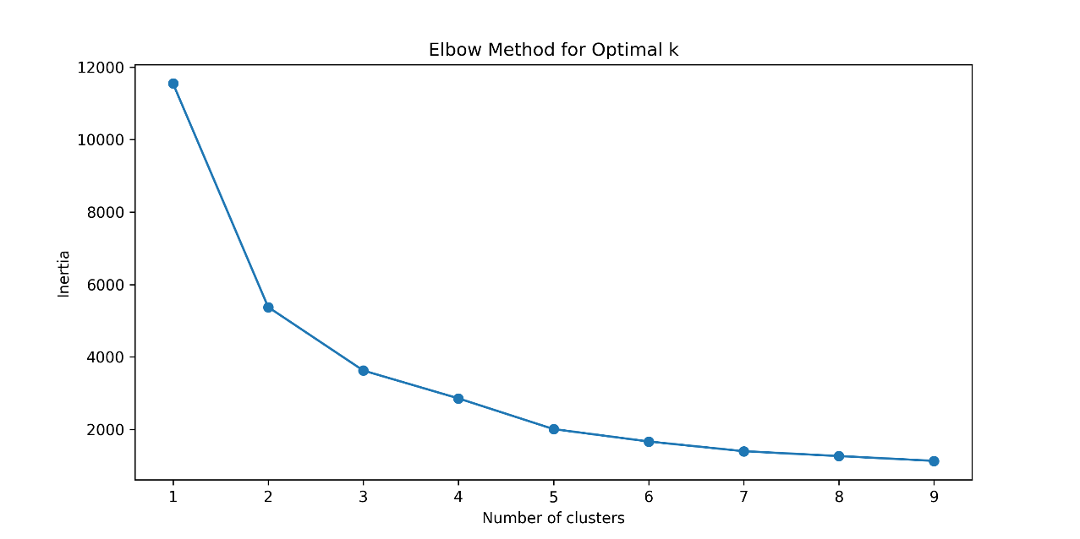

Figure 1: Elbow Method for Optimal k

Cluster Robustness: Validation via Hierarchical Clustering
To assess the reliability and robustness of the K-means clustering results, hierarchical clustering was performed using Ward’s linkage. This method builds clusters step-by-step by combining pairs of groups to minimize the total within-cluster variance.

The result is a dendrogram (Figure 2), a tree-like diagram that illustrates how individual laps (data points) were successively merged into clusters. The dendrogram shows how laps with similar telemetry profiles are linked at lower levels (shorter distances) and how clusters become progressively broader moving upward. The height (distance) at which branches merge indicates the similarity between merged clusters: shorter merges imply stronger similarity.

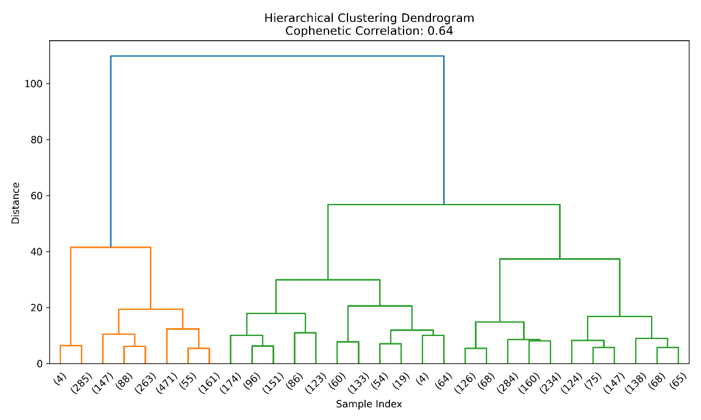
Figure 2: Hierarchical clustering dendrogram validating the integrity of the identified clusters.

To evaluate the fidelity of the dendrogram to the true pairwise distances, the cophenetic correlation coefficient was calculated. The result, 0.64, reflects moderate alignment between the hierarchical clustering structure and the original distance matrix. While this does not represent a high degree of fidelity, it provides partial support for the presence of stable grouping patterns. However, the moderate value also implies that the data's natural groupings are not sharply distinct, and some degree of overlap between clusters may exist.

To reinforce the evaluation of cluster quality, two additional internal validation metrics were applied:
- Silhouette Score: A value of 0.4655 indicates moderate intra-cluster cohesion and inter-cluster separation. Though not exceptionally high, this score suggests that the three-cluster structure is meaningful but not strongly separated. This implies that while the clusters capture stylistic tendencies, these are not strictly isolated, and some behavioral blending is likely.
- Davies–Bouldin Index: The score of 0.8519, where lower values indicate better-defined clusters, suggests that the identified clusters are reasonably compact and distinct. This provides further support for the coherence of the segmentation.

Collectively, these validation metrics imply that the clustering captures underlying behavioral regularities among drivers, but these are not absolute or cleanly partitioned. The clusters likely reflect dominant stylistic modes rather than fixed categories, consistent with the expectation that driver behavior is context-sensitive and may evolve across laps or circuits. This moderateness in validation supports the pragmatic use of clusters as analytical tools rather than definitive typologies.

Consequently, when interpreting the impact of driving styles on race outcomes (as examined in Hypothesis H₂), it is important to view these clusters as behavioral tendencies, not rigid labels. The modest separation between clusters also justifies the use of flexible, ensemble-based models (e.g., Random Forests), which can accommodate potential interaction effects and behavioral overlap in predictive modeling.

Behavioral Archetypes: Cluster Characterization
Analysis of average telemetry values across the three identified clusters revealed clear distinctions in driving behavior. As shown in Table 2 the clusters vary consistently across throttle usage, braking intensity, and average speed:

Cluster | ThrottleAvg (%) | BrakeAvg | SpeedAvg (km/h) | Driving Signature
1 | 69.06 | 0.18 | 214.67 | Aggressive: Sustained high-speed cornering with late, minimal braking
0 | 44.99 | 0.26 | 149.83 | Balanced: Moderate inputs, smooth transitions
2 | 34.15 | 0.17 | 141.69 | Cautious: Conservative speed management with optimized braking points
Table 2: Average telemetry metrics per cluster.
- Cluster 1 exhibited the highest average throttle and speed with minimal brake input, consistent with a highly aggressive driving style focused on sustained momentum and late braking.
- Cluster 0 showed moderate values across all inputs, aligning with a balanced approach that blends pace with control.
- Cluster 2 recorded the lowest throttle and speed metrics, with restrained braking, indicating a cautious or precision-oriented style that prioritizes stability over raw speed.

These differentiated profiles align closely with Hypothesis H₁, confirming that distinct behavioral patterns can be identified directly from qualifying telemetry data. The consistency of these averages within each group reinforces the interpretability and coherence of the cluster labels.

Beyond statistical separation, the dominance of specific telemetry variables in each cluster reveals important insights about driver behavior. In Cluster 1 (Aggressive), the combination of high average throttle (69.06%), low brake input (0.18), and high average speed (214.67 km/h) suggests drivers who prioritize momentum conservation and late braking. These drivers tend to extract lap time by staying on the throttle longer into corners and minimizing deceleration phases, a style that excels on circuits with flowing, high-speed sections.

Cluster 2 (Cautious), on the other hand, is defined by significantly lower throttle usage (34.15%) and speed (141.69 km/h), yet still exhibits restrained braking (0.17). This counterintuitive pattern, low throttle but not extreme braking, may suggest drivers who modulate speed gradually and emphasize smooth cornering rather than aggressive entries. In this cluster, behavior may be shaped by external risk factors (e.g., traffic, tire preservation) or internal preferences for minimizing mistakes under pressure. ThrottleAvg is low because these drivers delay acceleration out of corners or coast more frequently to maintain control, especially on technical or street circuits.

Cluster 0 (Balanced) falls between the two extremes, with moderate telemetry values across all features. Here, no single input dominates, which reflects an adaptable style that blends aggression and caution depending on the situation. Balanced drivers may adjust their pace dynamically throughout a qualifying lap, responding to tire grip, track evolution, or car handling without leaning too heavily on any one technique. The even distribution of variable means reinforces that no one metric is especially dominant, these drivers optimize overall flow rather than individual corners.

These behavioral archetypes suggest that qualifying strategies are not solely defined by outright pace, but by how drivers apply and balance their inputs under time pressure. The variation in dominant features, ThrottleAvg in aggressive styles, more evenly distributed metrics in balanced styles, and subdued inputs in cautious ones, reflects different philosophies of risk, control, and car exploitation.

Visual Validation: PCA Biplot of Cluster Separation
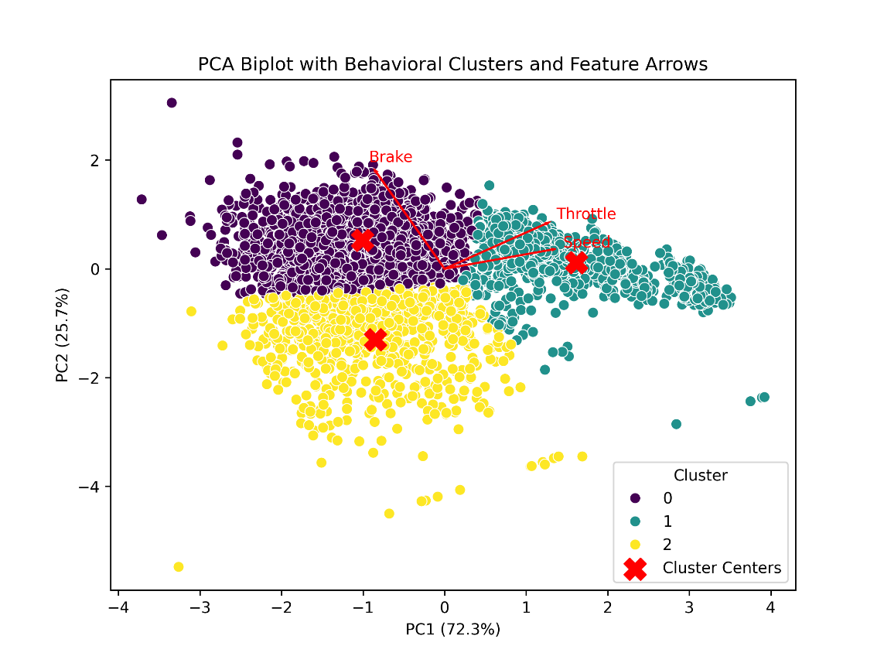
The PCA biplot (Figure 3) offers a visual representation of how driver behavior clusters are distributed in the reduced two-dimensional space created by Principal Component Analysis. This visualization illustrates not only the grouping of individual qualifying laps but also the influence of underlying telemetry variables, ThrottleAvg, BrakeAvg, and SpeedAvg, on the principal components.
Figure 3 : PCA Biplot with Behavioral Clusters and Feature Arrows.

Each data point on the plot represents a single qualifying lap, color-coded by its assigned cluster. The tight groupings indicate strong internal consistency within behavioral types, while the spatial separation across clusters confirms that these styles are meaningfully distinct in how drivers apply throttle, brake, and carry speed.

Overlaying the plot, feature arrows depict the influence of the original telemetry inputs on the principal components:

- Arrows for Throttle and Speed align closely, both strongly contributing to PC1.
- The Brake arrow diverges, loading more heavily on PC2, highlighting its unique behavioral role.

Finally, cluster centroids marked with red Xs indicate the average position of each group in PCA space, clearly occupying separate regions. This visual clarity supports the interpretability of the unsupervised learning results and confirms the effectiveness of PCA in structuring driver behavior for clustering.

Longitudinal Variation in Driving Styles (2021–2023)

To further explore Hypothesis H₁, that Formula 1 drivers exhibit distinct driving styles identifiable through qualifying telemetry, this section examines how the prevalence of these behavioral patterns evolved over the 2021–2023 seasons. While previous sections established the existence and structure of three distinct clusters (Aggressive, Balanced, and Cautious), the current analysis investigates their temporal distribution to assess whether style adoption varies by season.

Figure 4 presents the distribution of qualifying laps per cluster, aggregated by season. Cluster 0 corresponds to Balanced drivers, Cluster 1 to Aggressive, and Cluster 2 to Cautious.
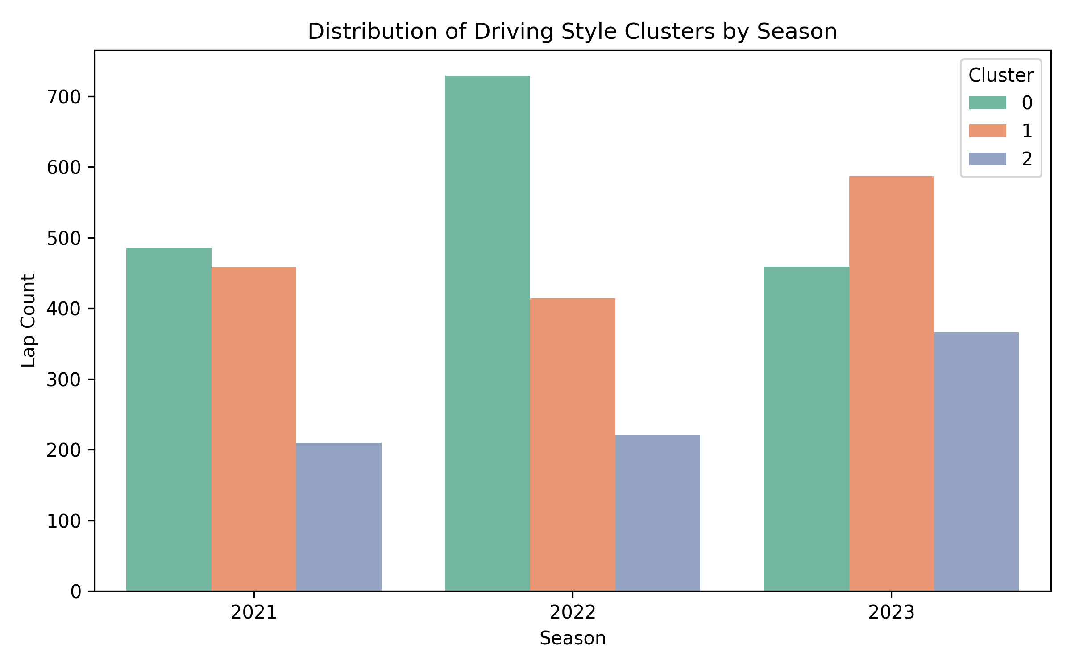
Figure 4: Distribution of Driving Style Clusters by Season

In 2021, the field was predominantly split between Balanced and Aggressive styles, with Cautious driving remaining infrequent. This suggests that drivers relied largely on adaptable, moderate inputs or assertive approaches to lap execution. The comparable presence of both profiles indicates a relatively stable regulatory environment, where driver styles reflected strategic preference more than technical uncertainty.

The 2022 season, marked by significant regulatory overhaul, including the return of ground effect aerodynamics and simplified car geometries, shows a sharp increase in Balanced driving. Cluster 0 laps rose substantially, while Aggressive (Cluster 1) and Cautious (Cluster 2) styles remained steady or declined slightly. This shift likely reflects a cautious adaptation period, where teams and drivers adopted more controlled and generalized driving styles to manage tire behavior, aerodynamic sensitivity, and unfamiliar car dynamics. Balanced driving here represents a strategic middle ground, emphasizing adaptability and consistency under unknown conditions.

By 2023, a clear behavioral divergence emerged. The proportion of Aggressive laps rose markedly, surpassing Balanced driving for the first time in the dataset. This reemergence of Cluster 1 suggests a return to assertive driving strategies as teams optimized car setup and grip understanding. The concurrent increase in Cautious laps also implies a widening performance gap within the field, with some drivers adopting conservative styles to avoid track limits violations or optimize car control on demanding layouts. The decline in Balanced driving signals polarization between risk-taking and error minimization strategies.

These findings align closely with Hypothesis H₁. Not only are distinct behavioral patterns observable across telemetry variables, but their distribution over time reflects strategic adaptation to evolving technical and competitive contexts. The cluster proportions are not fixed; instead, they respond to broader factors such as regulation changes, circuit profiles, and team confidence in car performance.

Moreover, this longitudinal analysis underscores that driver style is not merely an intrinsic trait but a context-sensitive behavioral mode, activated under specific environmental or strategic pressures. It also reinforces the utility of unsupervised clustering as a tool to reveal latent adaptation strategies, deepening the behavioral interpretability of telemetry data in elite motorsport.

Taken together, the PCA biplot, hierarchical clustering dendrogram, validation metrics, and longitudinal distribution all support the existence of consistent, interpretable driver behavior patterns across seasons. While the clusters show some degree of overlap, their stability and coherence across 2021–2023 affirm their analytical value. These behavioral groupings form the foundation for the next stage of analysis, where their relationship to race performance is examined through predictive modeling in line with Hypothesis H₂.

H₂: Predictive Modeling Across Behavioral Clusters

Model Performance Overview
The predictive models were evaluated using test set accuracy, F1 score, and five-fold cross-validation accuracy, with results summarized in Table 3.

Driving Style | Accuracy | F1 Score | CV Accuracy (±Std)
Aggressive | 88.7% | 0.893 | 63.9% ± 4.9%
Balanced | 81.8% | 0.839 | 62.6% ± 7.8%
Cautious | 81.6% | 0.857 | 48.2% ± 7.4%
Table 3: Random Forest model performance metrics by driving style
The test accuracy measures how often the model correctly predicted a points finish on a held-out validation set. All three models exceed 80% accuracy, indicating strong performance. However, accuracy alone may be misleading in datasets where non-point finishes (class 0) dominate, which is why the F1 Score is crucial.

The F1 Score incorporates both:
- Precision (how many predicted point-scorers actually scored points)
- Recall (how many actual point-scorers were correctly identified)
The Aggressive model achieves the highest F1 score (0.893), demonstrating a very strong ability to detect successful race outcomes within this behavioral group. This suggests that the racing patterns of aggressive drivers are more predictable and structured—when they perform well, their telemetry and pace characteristics are clearly defined, allowing the model to learn from them effectively.
In contrast, Balanced and Cautious drivers show slightly lower F1 scores (0.839 and 0.857, respectively). While still strong, this drop reflects that these groups contain more strategic variation or nuanced behavior, making them more challenging to model using a fixed set of features.

Cross-validation offers a more conservative and realistic estimate of generalization, especially important in motorsport data where track conditions, car setups, and strategy can vary significantly.
The Aggressive model retains a strong mean cross-validated accuracy of 63.9%, with low variance (±4.9%). This indicates that the predictive patterns are robust and stable across multiple circuits and events.
The Balanced model also generalizes well (62.6% ± 7.8%), suggesting that while it is slightly less accurate overall, its prediction reliability across different race contexts is competitive.
However, the Cautious model shows a large drop from test accuracy (81.6%) to cross-validation accuracy (48.2%), along with the highest standard deviation (±7.4%). This discrepancy indicates that while the model performs well on the test set, it struggles to generalize, likely due to greater heterogeneity in how cautious drivers manage their races across circuits.

This instability supports H₂ by showing that the relationship between driver telemetry and race outcomes is more complex and less uniform for some styles than others. For Cautious drivers in particular, the features used (pace, balance, consistency) may capture only part of the story, possibly missing hidden contextual variables like strategy conservatism or environmental adaptability.

Feature Importance Across Driving Styles
To understand how different aspects of driver performance contribute to successful race outcomes, the relative importance of each engineered feature was extracted from the trained Random Forest models. These features, AvgPace, PeakPace, PaceConsistency, and SectorBalance, were specifically designed to represent different dimensions of driver performance during race sessions, as previously detailed in the Methodology section.

Aggressive Drivers
The feature importance plot for the Aggressive cluster (Figure 5) highlights LapTime_AvgPace as the most influential variable, followed closely by LapTime_PeakPace and LapTime_PaceConsistency. This reflects a style built around maintaining high velocity and extracting maximum lap-time gains through sharp bursts of speed. These drivers often operate near the edge of car performance, where overall pace and short-duration speed exploitation (e.g., clean air laps or undercut attempts) are decisive.
Notably, SectorBalance is the least important feature in this group. This can be interpreted behaviorally: aggressive drivers are less focused on maintaining rhythm or equal time distribution across sectors. Instead, they might push harder in certain corners or sectors where the car allows, leading to asymmetric performance. The model detects that such inconsistencies do not penalize their success; rather, they reflect tactical aggression and performance peaks, not steady execution. This insight aligns with findings in Patil et al. (2023), where successful overtaking and high-risk strategies were tied more to pace bursts than to uniform lap structure.
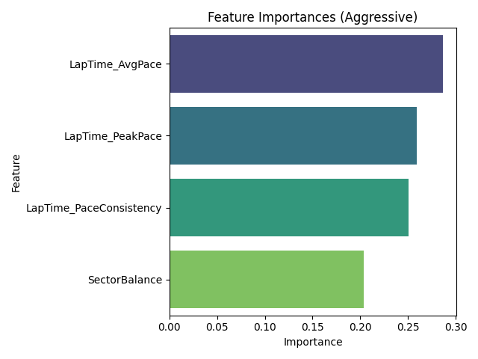
Figure 5: Feature Importance Plot - Aggresive

Balanced Drivers
In the Balanced cluster (Figure 6), LapTime_AvgPace again emerges as the top feature, suggesting that across styles, maintaining a solid average pace is universally beneficial. However, the gap between features is smaller here: PaceConsistency and PeakPace are nearly equal in importance, and SectorBalance also holds comparable weight. This reflects the essence of the Balanced style itself, no single performance trait dominates, and success relies on a more distributed set of competencies.
This profile fits drivers who respond dynamically to grip evolution, traffic, and tire degradation without extreme commitment to one performance trait. From a modeling perspective, their success arises from combinations of solid pace, stability under changing conditions, and composure across sectors. These findings also echo the multi-feature dependency noted by Cui et al. (2019) in tennis, where balanced performance styles correlated with broad performance profiles rather than single-factor dominance.
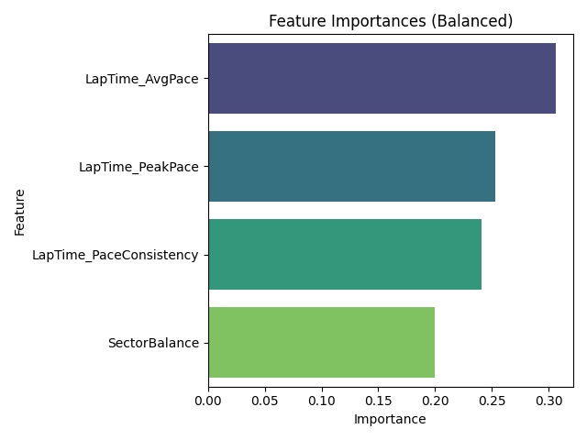
Figure 6: Feature Importance Plot - Balanced
Cautious Drivers
The Cautious group (Figure 7) shows a slightly different pattern. While LapTime_AvgPace still leads, its margin over other features is narrower than in other styles. PaceConsistency and PeakPace are both nearly as important, and SectorBalance rises in relative contribution. This suggests that success for cautious drivers is more dependent on maintaining lap stability and controlling pacing across track sectors, possibly compensating for lower overall speed with strategic consistency and smooth driving.
These drivers may adopt smoother throttle application, earlier braking, and more predictive cornering lines. The model’s higher reliance on PaceConsistency and SectorBalance supports this interpretation: even minor disruptions in rhythm or corner execution could disproportionately affect their chances of scoring points. This finding aligns with racecraft research such as Batikas (2024), who emphasized the role of stable driving and adaptive pace management in circuits with low overtaking potential.
Furthermore, the relatively low generalizability of the Cautious model (CV accuracy = 48.2%) reflects that consistent strategies vary more across circuits, depending on technical layout, tire wear patterns, and safety car likelihood, none of which are directly captured in the current feature set.

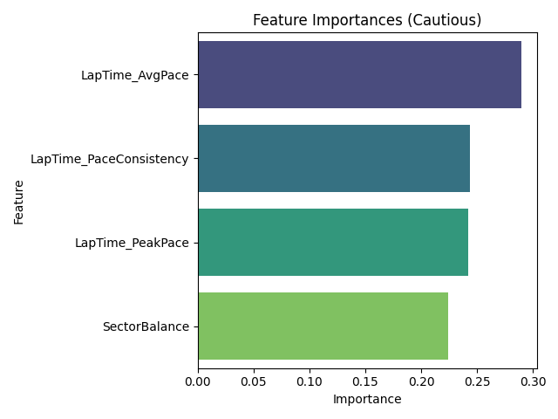
Figure 7: Feature Importance Plot - Cautious

These stylistic variations in feature importance directly support Hypothesis H₂, which posits that the predictive value of race features varies by driving style. Aggressive drivers benefit most from raw and peak pace, Balanced drivers depend on a spread of performance metrics, and Cautious drivers lean more on control and rhythm.
Compared with existing literature, this analysis adds nuance by incorporating stylistic segmentation into predictive modeling. While prior studies (e.g., Patil et al., 2023) demonstrated that lap time and strategy features can predict success, this study shows how and why those features vary in importance depending on the behavioral profile of the driverrevealing new layers of interpretability for applied motorsport analytics.

Confusion Matrix Insights
The confusion matrices for each driving style cluster provide a granular view of the classification performance of the Random Forest models by breaking down true positives, true negatives, false positives, and false negatives. This allows for a more nuanced evaluation of how well each model distinguishes between drivers who finished in the points versus those who did not.

Aggressive Drivers
The confusion matrix for aggressive drivers (Figure 8) shows very strong performance, with most predictions correctly identifying whether a driver scored points. The number of true positives (points correctly predicted) is particularly high, indicating that the model excels at recognizing success in this style group. There are few false positives, suggesting the model is not overly optimistic, and false negatives are minimal, showing little underestimation of successful outcomes. This complements the high F1 score (0.89) and accuracy (0.89), indicating a reliable balance between precision and recall.
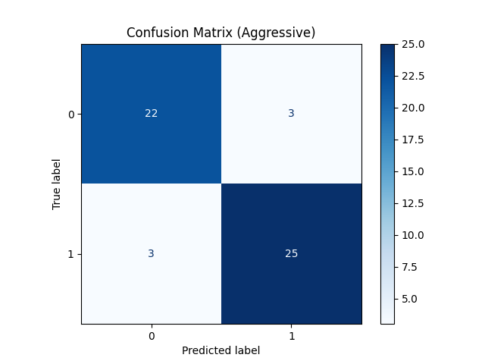
Figure 8: Confusion Matrix - Aggressive

Balanced Drivers
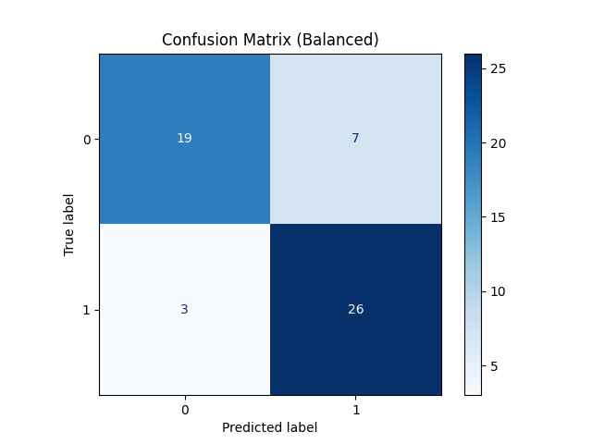
The balanced group (Figure 9) also shows a well-performing model, though slightly less confident than the aggressive model. The number of true positives remains substantial, but false positives are slightly more pronounced. This could suggest that balanced driving yields outcomes that are more context-sensitive or harder to model precisely. Still, the F1 score of 0.84 and accuracy of 0.82 reflect strong classification fidelity. The confusion matrix highlights the model's effectiveness while revealing room for improvement in distinguishing borderline cases.
Figure 9: Confusion Matrix- Balanced

Cautious Drivers
The cautious cluster (Figure 10) reveals a slightly different pattern. Although the true positive count remains high, indicating good detection of point-scoring performances, there is an increase in false positives compared to the other styles. This implies the model may overpredict success for cautious drivers. One possible explanation is that their race outcomes are more dependent on external factors (e.g., race attrition, strategy), which aren't captured by the current feature set. The F1 score of 0.86 and accuracy of 0.82 are still strong, but the matrix hints at the model's limitations in capturing the nuanced variability in this group.
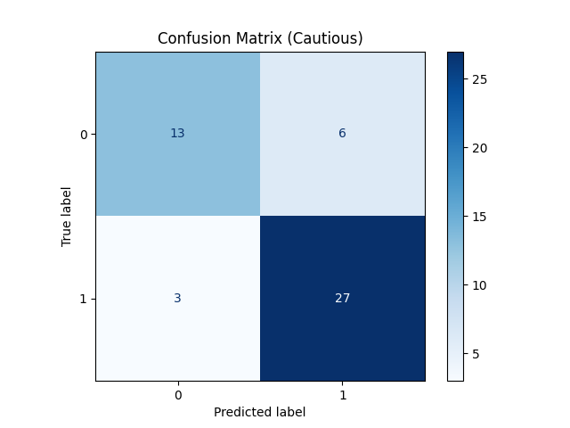
Figure 10: Confusion Matrix- Cautious

These results reinforce Hypothesis H₂, showing that not only feature importance but also prediction reliability varies by driving style. Incorporating style-aware models allows for better-calibrated expectations of model performance, particularly important in operational or real-time applications (e.g., mid-race strategy tools or driver analytics dashboards).

Comparative Evaluation Across Models
To critically assess the suitability of the Random Forest approach and validate the robustness of the predictive framework, two alternative classifiers were trained and evaluated using the same feature set and stratified splits: Support Vector Machines (SVM) and Extreme Gradient Boosting (XGBoost). This comparative analysis not only addresses potential model bias but also explores whether certain behavioral clusters, especially the Cautious group, where Random Forest exhibited high variance, might benefit from different modeling strategies.

Support Vector Machine (SVM): Performance Summary
The SVM model yielded the weakest performance across all driving styles, shwon in Table 4.

Driving Style | Accuracy | F1 Score | CV Accuracy (±Std)
Aggressive | 64.2% | 0.698 | 55.9% ± 7.9%
Balanced | 56.4% | 0.613 | 55.6% ± 10.1%
Cautious | 51.0% | 0.586 | 47.8% ± 11.0%
Table 4: SVM model performance metrics by driving style
These results indicate that SVM struggles to capture the nuanced relationships between the engineered features and race outcomes. Despite its theoretical appeal for low-dimensional classification tasks, SVM appears to underperform in this context, likely due to noise, limited sample sizes within clusters, and the inherent non-linear nature of race data. The cautious group in particular exhibits low cross-validation accuracy and high standard deviation, reinforcing earlier concerns about generalizability.

Extreme Gradient Boosting (XGBoost): Performance Summary
XGBoost offered performance metrics that were intermediate between SVM and Random Forest, as seen in Table 5.

Driving Style | Accuracy | F1 Score | CV Accuracy (±Std)
Aggressive | 86.8% | 0.877 | 60.8% ± 6.1%
Balanced | 76.4% | 0.794 | 60.8% ± 5.2%
Cautious | 89.8% | 0.921 | 48.2% ± 7.3%
Table 5: XGBoost model performance metrics by driving style
While XGBoost matched or even slightly outperformed Random Forest on test accuracy and F1 score, particularly for cautious drivers, it did not resolve the core issue identified in Random Forest: high cross-validation variability in the Cautious group. In fact, the cross-validation accuracy remained low (48.2%) and comparable in instability (±7.3%), indicating that even more sophisticated boosting techniques struggle to generalize reliably for this behavioral cluster.

Interpretation and Implications

The model comparison reinforces that while Random Forest performs competitively overall and provides interpretable feature importances, its superiority is not absolute. XGBoost approaches Random Forest's performance for Aggressive and Balanced drivers and even slightly exceeds it for the Cautious group in terms of F1 score. However, this gain is undermined by comparable instability in cross-validation, suggesting that the features engineered in this study may lack sufficient contextual depth, particularly for drivers whose success is shaped more by strategy, attrition, or external race dynamics.
The SVM model, in contrast, consistently underperforms, confirming its relative unsuitability for this domain, possibly due to its lower tolerance for feature interaction complexity and noise.

These findings support two key conclusions:
Model Generalization Is Style-Dependent: The Cautious cluster exhibits unpredictable generalization performance across all models, hinting at underlying race dynamics not captured by the current feature set. This aligns with the belief that contextual variables, such as pit strategy, safety car influence, or teammate interactions, may be critical to performance in this group.
Random Forest Remains a Balanced Choice: Despite slightly better point estimates from XGBoost, Random Forest maintains competitive accuracy with better interpretability and consistency, making it a justified baseline. Its performance, particularly for Aggressive and Balanced drivers, is both strong and stable, supporting its continued use in behavior-aware motorsport analytics.

In future work, expanding the feature space with contextual and environmental variables could further stabilize modeling for Cautious drivers. For now, the inclusion of alternative classifiers affirms that the observed performance patterns are not artifacts of model selection but reflect genuine differences in behavioral predictability across styles.

5. Discussion

Revisiting the Hypotheses
This study was designed to investigate two central research questions. The first (H₁) proposed that distinct Formula 1 driving styles, aggressive, balanced, and cautious, can be revealed through unsupervised learning on qualifying telemetry data. The second hypothesis (H₂) asserted that the predictive influence of performance-related race features varies according to these behavioral clusters. Together, these hypotheses framed a dual methodological and conceptual inquiry: are driver styles meaningfully detectable in data, and do those styles require different analytic lenses to understand performance outcomes?
The results validate both hypotheses. H₁ was supported by the identification of three well-separated behavioral clusters using PCA and K-means, further confirmed through hierarchical clustering. H₂ was affirmed through the performance of driving-style-specific Random Forest models, which not only achieved high classification metrics but also demonstrated stylistic variation in feature importance and generalization behavior. These outcomes establish a foundational link between telemetry-defined behavior and style-specific performance prediction.

Interpretation of Findings
The findings of this study offer a behaviorally segmented perspective on how different telemetry-derived driving styles, aggressive, balanced, and cautious, relate to race performance outcomes. These insights complement, contrast with, and extend existing literature in motorsport analytics by highlighting that the predictive value of performance features is not uniform, but style-dependent.
The observation that aggressive drivers achieved the highest F1 scores and cross-validated accuracy aligns with previous research emphasizing the predictability of high-commitment driving styles. Nimmala (2024) and Batikas (2024) both associate aggressive behaviors with consistent performance signals, particularly in qualifying or early-race stints. However, while Nimmala’s work focused on static throttle metrics and Batikas emphasized pit stop strategy optimization clusters, this study diverges by using unsupervised clustering from qualifying telemetry as the foundation for prediction. This allows for a dynamic, data-driven identification of aggressive traits, defined by high ThrottleAvg and SpeedAvg, and shows their concrete predictive utility in modeling race outcomes. Unlike prior research, which often treated aggression as a monolithic feature or outcome, the present analysis operationalizes it as a behavioral cluster grounded in input data, enabling more robust predictive modeling across styles.
Conversely, cautious drivers showed the weakest generalization in cross-validation, despite high test accuracy. This instability reflects findings by Shu and Ye (2022), who reported greater variance and unpredictability among conservative drivers due to contextual dependencies such as tire compound choice or defensive positioning under varying track conditions. While their study highlighted the challenge of modeling adaptive race behaviors, it did not quantify how this affects model performance. This study provides that missing link: the cautious cluster exhibits higher reliance on features like PaceConsistency and SectorBalance, but these are less consistently tied to point-scoring success across circuits. This discrepancy adds depth to the literature by empirically confirming that cautious driving is not only harder to model, but also more susceptible to unseen race dynamics. It also underscores the need to incorporate contextual features in future models, a limitation acknowledged in this study.
The balanced cluster exhibited intermediate predictability and more evenly distributed feature importances. This reflects the notion of adaptive control described by Marr (2023), where success arises not from any single metric but from composure and flexibility. In contrast to prior studies that treated average pace as a globally dominant predictor (e.g., Batikas, 2024), this study reveals that in balanced styles, predictive strength is dispersed across multiple features. This supports the view that a one-size-fits-all performance metric fails to capture the complexity of race success, and affirms the value of behavioral segmentation.
Taken together, these findings clarify the original contribution of this study: the integration of unsupervised telemetry-based clustering with supervised race outcome prediction. While Cui et al. (2019) previously combined behavioral segmentation and performance modeling in tennis, such integration remains rare in motorsport literature. Moreover, this study uniquely bases its segmentation on qualifying telemetry data, a novel angle that captures baseline driving tendencies prior to the influence of race dynamics (e.g., fuel loads, traffic, pit windows). This methodological distinction allows for a purer behavioral profiling, unlike previous approaches that inferred style from aggregate outcomes or subjective annotations.
Thus, the study advances the literature by demonstrating not only that driving styles affect race success, but that predictive accuracy itself is conditioned by behavioral group. This has direct implications for AI modeling in motorsport, where behavior-specific models can outperform global models by accounting for latent heterogeneity in decision-making patterns.

Practical Implications
This study provides several concrete insights with direct applicability in performance engineering, driver coaching, and strategic planning within Formula 1. These implications are particularly relevant not only for top-tier teams with advanced simulation infrastructure, but also for smaller outfits operating under FIA-imposed budget caps.

First, the use of qualifying telemetry for behavioral clustering offers a data-driven alternative to traditional classifications based on reputation, points standing, or subjective assessments. The derived driving styles are grounded in quantitative telemetry inputs rather than narrative assumptions, enhancing the objectivity and reproducibility of performance profiling. Implementing such clustering pipelines enables teams to tailor coaching and analytics strategies more precisely. For example, aggressive drivers might benefit from visualizations emphasizing optimal throttle traces and entry speeds, while cautious drivers may benefit more from feedback on pacing rhythm and sector transitions.

Second, the predictive modeling results highlight that different driver styles benefit from distinct performance strategies. Aggressive drivers are most successful when maximizing average and peak pace, suggesting that car setups emphasizing low downforce and reduced drag are most appropriate. In contrast, cautious drivers demonstrate better outcomes when consistency and intra-lap balance dominate, indicating that high-downforce setups, stable suspension tuning, and brake bias favoring control over reactivity are more effective. Balanced drivers show distributed feature importance, and their performance depends on adaptive setups that maintain equilibrium between speed and control. Teams can operationalize these insights by mapping driver styles to circuit characteristics and tailoring setup parameters accordingly, rather than adopting uniform configurations across events.

Moreover, the observed drop in generalization performance for cautious drivers, where cross-validated accuracy fell to 48.2%, suggests that behavior-specific modeling is essential for maintaining predictive fidelity. A single predictive model applied indiscriminately across all styles risks misrepresenting the underlying behavioral variability. In practice, this means teams should develop style-specific predictive models and allocate simulation resources to scenario testing that reflects each driver’s typical behavioral tendencies. For example, simulations for aggressive drivers should emphasize overtaking scenarios and entry-speed variance, while simulations for cautious drivers should include tire-saving strategies and stability under variable grip.

Finally, the cost-effectiveness of this approach makes it particularly advantageous for midfield or lower-budget teams. Because telemetry-based clustering and segmented modeling rely primarily on data already collected during normal sessions, implementation costs remain low. Even teams without full-scale simulators or in-house data science divisions can apply this framework using open-source tools such as FastF1 and scikit-learn. By focusing technical resources on the variables most predictive for their driver’s behavioral profile, smaller teams can increase setup efficiency and strategic clarity without requiring complex infrastructure. In doing so, they can close performance gaps not through raw investment, but through behavioral intelligence.

Limitations and Considerations
Despite the strengths of this study in combining telemetry-driven behavioral segmentation with outcome-based predictive modeling, several methodological and data-related limitations should be acknowledged.

Impact of Data Imputation

A substantial portion of the raw dataset contained missing timing values, particularly for LapTime and sector times. While the cleaning pipeline addressed these gaps through a two-stage process: exact arithmetic reconstruction and fallback to driver-circuit median imputation, the use of median values introduces a possible bias. This can potentially underrepresent within-driver variability or session-specific anomalies, particularly at circuits with high lap-to-lap fluctuation such as Monaco or Baku.

Limited Circuit Diversity
The analysis was conducted on telemetry from six Grand Prix circuits, strategically chosen to cover different layout archetypes (street, high-speed, technical). While this ensured variation in driving demands, it also constrains the generalizability of the findings. F1 features over 20 races per season, each with distinct environmental and strategic characteristics. Consequently, the current behavioral clusters may not capture the full stylistic range exhibited by drivers across less-represented or unique venues (e.g., Suzuka, Spa, or Las Vegas). The predictive models may likewise generalize poorly to circuits with different dynamics than those analyzed.

Potential Bias and Noise in FastF1 Telemetry
Although FastF1 is a well-established open-source library for Formula 1 telemetry extraction, it relies on unofficial access to the FOM (Formula One Management) broadcast feed and session metadata. This introduces potential inaccuracies stemming from packet transmission errors, delayed telemetry syncing, or missing sensor values. While FastF1 documentation warns of occasional inconsistencies, especially under unstable session conditions like red flags or wet weather, these limitations are not fully observable during automated data collection. As such, downstream clustering or modeling may have unknowingly incorporated data artifacts or distorted timing inputs, particularly during qualifying laps that were aborted or affected by track events.

Exclusion of Contextual Race Factors
The current framework intentionally focused on telemetry-derived behavioral indicators and race performance summaries (e.g., pace, consistency, sector balance). However, it excluded broader strategic and contextual factors such as tire compound usage, pit stop timing, track temperature, weather fluctuations, and in-race incidents. These factors are often pivotal in determining race outcomes, especially for behaviorally conservative drivers. Their omission may explain the limited generalization of the cautious cluster model and potentially reduce the explanatory power of telemetry-only predictors in real-world race contexts.

Future Research Directions
This study opens several avenues for future research. One promising extension would be to incorporate real-time weather, safety car deployment, or pit stop data to account for contextual variability, especially relevant for cautious drivers. Additionally, integrating psychometric or cognitive profiles (if available) could help link telemetry-derived styles with underlying psychological traits.
From a technical standpoint, employing more interpretable models (e.g., rule-based learners or neural-symbolic hybrids) could enhance transparency, especially for use in driver coaching. Moreover, testing this approach on junior formulae or sim racing datasets could validate whether these patterns generalize across different competitive tiers.

6. Conclusion
This dissertation demonstrates that modern data science techniques, specifically unsupervised learning and behavior-aware predictive modeling, can extract and leverage meaningful insights from Formula 1 telemetry data. By validating Hypothesis H₁, the research establishes that distinct, interpretable driving styles can be objectively identified from qualifying data. These behavioral archetypes, aggressive, balanced, and cautious, are not merely descriptive; they significantly influence how race performance should be predicted, as supported by Hypothesis H₂.

Through a custom feature engineering pipeline and targeted Random Forest models, the study showed that each driving style benefits from a unique set of predictive indicators. Aggressive drivers respond most strongly to raw pace metrics, while cautious drivers depend more on consistency and sector management. Balanced drivers, true to their name, require a blend of all features for optimal predictive accuracy.
This behavior-specific modeling framework contributes to the emerging field of interpretable AI in sports analytics and offers actionable insights for performance engineering, driver development, and race strategy. As motorsport continues to embrace data-driven methodologies, this research provides a scalable foundation for future work that respects both the art and science of elite driving.

References

- Batikas, M. (2024). Optimizing race strategy: A machine learning model for predicting Formula 1 pit stop timing [Master’s thesis, Universidade Nova de Lisboa]. RUN Repository. https://run.unl.pt/handle/10362/175111
- Bishell, A. (2006). Machine learning and New Zealand horse racing prediction (Bachelor’s report). Department of Computer Science, Massey University, New Zealand.
- Breiman, L. (2001). Random forests. Machine Learning, 45(1), 5–32. https://doi.org/10.1023/A:1010933404324
- Cui, Y., Gómez, M. Á., Gonçalves, B., & Sampaio, J. (2019). Clustering tennis players’ anthropometric and individual features helps to reveal performance fingerprints. European Journal of Sport Science, 19(8), 1032–1044. https://doi.org/10.1080/17461391.2019.1577494
- Duman, A., Eyüp, E., Sennaroğlu, B., & Tuzkaya, G. (2021). A cluster analysis of basketball players for each of the five traditionally defined positions. Proceedings of the Institution of Mechanical Engineers, Part P: Journal of Sports Engineering and Technology. https://doi.org/10.1177/17543371211062064
- FastF1. (n.d.). FastF1 3.5.3 Documentation. Retrieved May 2025, from https://docs.fastf1.dev/
- Fédération Internationale de l'Automobile (FIA). (2025). Financial regulations: 2025 Formula 1 World Championship (Issue 23). https://www.fia.com
- Flinders, K. (2002, October 14). Football injuries are rocket science. vnunet.com. http://www.vnunet.com/vnunet/news/2120386/football-injuries-rocket%20science
- Han, J., Kamber, M., & Pei, J. (2011). Data mining: Concepts and techniques (3rd ed.). Morgan Kaufmann.
- Heilmeier, A., Graf, M., & Lienkamp, M. (2018). A race simulation for strategy decisions in circuit motorsports. In 2018 21st International Conference on Intelligent Transportation Systems (ITSC) (pp. 2986–2993). IEEE. https://doi.org/10.1109/ITSC.2018.8570012
- J, A., & Rastegari, H. (2013). A review of data mining techniques for result prediction in sports. ResearchGate. https://www.researchgate.net/publication/259082292_A_Review_of_Data_Mining_Techniques_for_Result_Prediction_in_Sports
- Jolliffe, I. T. (2002). Principal component analysis (2nd ed.). Springer. https://doi.org/10.1007/b98835
- Lloyd, S. P. (1982). Least squares quantization in PCM. IEEE Transactions on Information Theory, 28(2), 129–137. https://doi.org/10.1109/TIT.1982.1056489
- Marr, B. (2023, July 10). How artificial intelligence, data and analytics are transforming Formula One in 2023. Forbes. https://www.forbes.com/sites/bernardmarr/2023/07/10/how-artificial-intelligence-data-and-analytics-are-transforming-formula-one-in-2023/
- Miljković, D., Gajić, L., Kovačević, A., & Konjović, Z. (2010). The use of data mining for basketball matches outcomes prediction. In Proceedings of the 2010 IEEE 8th International Symposium on Intelligent Systems and Informatics (SISY) (pp. 309–312). IEEE. https://doi.org/10.1109/SISY.2010.5647440
- Nimmala, R. N. J. (2024). RACING INTO THE DATA AGE: SENSOR INTELLIGENCE, ADVANCED ANALYTICS, AND KAFKA IN FORMULA 1 RACE CAR. INTERNATIONAL JOURNAL OF ARTIFICIAL INTELLIGENCE &Amp; MACHINE LEARNING (IJAIML). https://iaeme.com/Home/article_id/IJAIML_03_01_006
- Patil, A., Jain, N., Agrahari, R., Hossari, M., Orlandi, F., & Dev, S. (2023). A Data-Driven Analysis of Formula 1 Car Races Outcome (pp. 134–146). https://doi.org/10.1007/978-3-031-26438-2_11
- Phillips, A. J. K. (2014). Uncovering Formula One driver performances from 1950 to 2013 by adjusting for team and competition effects. Journal of Quantitative Analysis in Sports, 10(2), 261–278. https://doi.org/10.1515/jqas-2013-0031
- Raschka, S., & Mirjalili, V. (2019). Python machine learning (3rd ed.). Packt Publishing.
- Rockerbie, D. &. E. S. (2021). Race to the podium: Separating and conjoining the car and driver in F1 racing. ideas.repec.org. https://ideas.repec.org/p/pra/mprapa/109053.html
- Shu, X., & Ye, Y. (2022). Knowledge Discovery: Methods from data mining and machine learning. Social Science Research, 110, 102817. https://doi.org/10.1016/j.ssresearch.2022.102817
- Sokal, R. R., & Rohlf, F. J. (1962). The comparison of dendrograms by objective methods. Taxon, 11(2), 33–40. https://doi.org/10.2307/1217208

